ITNPAI2 Assignment Report – Flower Classification
Computer Vision
3019061
2026

Contents
Robust Flower Image Classification Using Classical Features and MobileNetV2 1
Problem Statement and Contextualisation 1
Literature Review 2
Design and Methodology 5
Dataset 5
Experimental Design 5
Preprocessing and Feature Extraction 5
Models 6
Training Procedure 7
Application Implementation 8
Use of AI Tools 8
Results 9
Examples of Application 11
Ethics, Application, and Robustness 14
Conclusion 15
References 17

Robust Flower Image Classification Using Classical Features and MobileNetV2

Problem Statement and Contextualisation

Automatic flower classification is a useful computer vision task because flower species can vary substantially in colour, shape, pose, scale, lighting, stage of development, and background clutter. These sources of variation can make manual identification difficult and also create a challenging machine learning problem. Recent literature on flower classification notes that intra-class variation in colour, shape and texture is a major issue, while automated recognition can support applications in agriculture, environmental monitoring and botanical digitisation. (Barat, 2025)

The aim of this project was to develop a flower classification system that can distinguish between five flower categories from images: daisy, dandelion, roses, sunflowers and tulips. The project had two goals. The first was to compare a lightweight deep learning approach against classical computer vision baselines. The second was to build a small desktop application that allows a user to upload an image and view predictions from the trained models.

The main functional requirements of the application were:

- the user must be able to browse for an image from local storage
- the application must validate that the selected file is a supported image
- the image must be pre-processed consistently with the test pipeline
- the application must display predictions from the classical baseline(s) and the deep model
- the application must show the uploaded image and top predictions clearly
- the application must handle invalid files and missing model files safely.

This project is deliberately modest in scope, but it follows good research practice by defining a clear task, comparing against baselines, and evaluating the final system on a held-out test set.

Literature Review

Convolutional neural networks remain central to image classification because they exploit the spatial structure of images rather than treating pixels as an unordered vector. As Dumoulin and Visin explain, convolutional output size depends on the relationship between input size, kernel size, padding and stride, which makes careful preprocessing and architectural consistency important in practical CNN design. (Dumoulin, 2016)

For efficient computer vision, MobileNetV2 is especially relevant. Sandler et al. introduced MobileNetV2 as a mobile-friendly architecture built around depth-wise separable convolutions, inverted residual blocks, and linear bottlenecks. Their design reduces computation and memory requirements while maintaining strong classification performance, making it suitable for resource-constrained deployment. They also note that 3×3 depth-wise separable convolution can reduce computation by roughly a factor of 8–9 compared with standard convolution, while the inverted residual design improves efficiency and gradient flow. (Sandler, 2019)

This matters directly for the present project because the final system was not only evaluated as a model but also deployed inside a small desktop application. A model such as MobileNetV2 is therefore more appropriate than a very large network, since it offers a good trade-off between accuracy and inference cost. The MobileNetV2 paper frames this trade-off explicitly in terms of accuracy, parameter count, multiply-add operations and latency.

Recent flower-classification work also supports the choice of MobileNetV2. The MOBILENETV2 study on enhanced flower image classification reports that MobileNetV2 consistently outperformed a baseline MobileNet, and that optimizer choice influenced final performance. On its flower dataset, the best MobileNetV2 configuration achieved 96.67% accuracy with RMSProp, while the paper also cites earlier flower work in which a CNN achieved 91.6% accuracy and an SVM achieved 78.3%. It additionally cites work on Oxford17 and Oxford102 where transfer learning outperformed training from scratch. (Barat, 2025)

These findings informed my project in two ways. First, they suggested that a CNN should outperform classical methods such as SVM when learning directly from raw flower images. Second, they provided a realistic comparison target: not a claim that my model should match 96.67% exactly, since the datasets differ, but evidence that MobileNetV2 is a credible architecture for flower recognition.

I also reviewed Vision Transformer (ViT) as a modern alternative. Dosovitskiy et al. showed that ViT can perform extremely well when pre-trained on very large datasets, but they also report that on mid-sized datasets without sufficiently large-scale pretraining, ViT can underperform comparable ResNets because it lacks the strong image-specific inductive biases built into CNNs, such as locality and translation equivariance. Since this module project used a much smaller flower dataset and aimed for a practical desktop tool, a CNN-based approach was the more appropriate design choice. (Dosovitskiy, 2021)

Overall, the literature suggests a clear gap for a taught-module project: compare simple classical baselines against an efficient transfer-learning CNN on a practical flower-recognition task, then reflect not only on accuracy but also on deployment suitability.

Design and Methodology

Dataset

The project used a Kaggle flowers dataset arranged in an ImageFolder-style structure with five classes: daisy, dandelion, roses, sunflowers and tulips. Images were split into 70% training, 15% validation and 15% test using a stratified split to preserve class balance.

Experimental Design

The project compared three models:
- Random Forest baseline using handcrafted features.
- SVM baseline using the same handcrafted features.
- MobileNetV2 fine-tuned for five-class flower classification.

This created a fair comparison between classical computer vision and transfer learning. Initially the plan was to determine which of the classical computer vision models would be included in the desktop application, however during development it became apparent that the classicals models’ results were similar. So, it was decided to incorporate both in order to show the potential of the MobileNetV2 model.

Preprocessing and Feature Extraction

For the classical models, each image was resized to 224 × 224 and converted to RGB. Two handcrafted feature types were extracted:

- HSV colour histograms to capture colour distribution;
- Histogram of Oriented Gradients (HOG) to capture edge and gradient structure.

These were concatenated into a single feature vector and used as input to the Random Forest and SVM classifiers.

For MobileNetV2, images were also resized to 224 × 224, converted to tensors, and normalised using ImageNet mean and standard deviation. During training, data augmentation was applied using random resized crops, horizontal flips and colour jitter. This was intended to improve robustness to variation in viewpoint and colour.

Models

The Random Forest classifier was used as a tree-based baseline because it is simple, robust and works reasonably well on tabular feature vectors.

The SVM baseline used an RBF kernel with feature scaling inside a pipeline. SVM is a sensible comparator because older flower-classification work still reports SVM as a meaningful classical baseline, although CNNs tend to outperform it on image tasks. (Barat, 2025)

The deep model used MobileNetV2 with the final classifier layer replaced by a five-class output layer. This follows the transfer-learning idea suggested both by the original MobileNetV2 architecture and by later flower-classification work using lightweight CNNs.

Training Procedure

MobileNetV2 was trained using transfer learning for 12 epochs with AdamW, a learning rate of 1e-3, weight decay of 1e-4, and early stopping based on validation macro F1. The best model weights were retained.

The classical baselines did not require epoch-based training in the same way. Random Forest hyperparameters were set to:

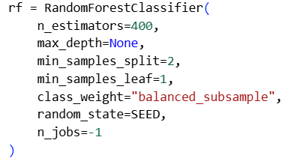

While the SVM used:
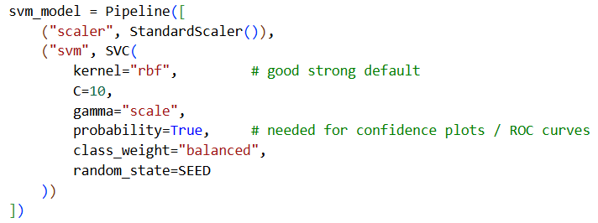

Hyperparameter tuning in this project was modest rather than exhaustive, which is appropriate for the scale of the assignment.

Application Implementation

A desktop application was built in Python using Tkinter. The application loads saved model files, validates image file types, preprocesses images using the same test-time transformations, and displays predictions from Random Forest, SVM and MobileNetV2 beside the uploaded image. This ensured that the project functioned not just as an experiment but as a usable classification tool.

Use of AI Tools

AI tools were used to assist with boilerplate coding, debugging and interface development. However, all generated code was reviewed, edited and tested manually. Model training, evaluation, debugging of data paths, and interpretation of results were carried out by myself. Overall, use of AI was limited to development assistance rather than replacing experimental design or analysis.

Results

Model | Accuracy | Macro F1
mobilenetv2 | 0.940109 | 0.938199
svm | 0.537205 | 0.52857
random_forest | 0.515426 | 0.49687

The overall pattern was MobileNetV2 produced the most accurate results and held a higher confidence, the SVM was second and RF third with both holding similar rates of accuracy and Marco F1. This is consistent with the literature, which suggests that learned convolutional features are generally stronger than handcrafted colour-and-gradient descriptors for complex flower variation. It is also broadly consistent with the 2025 MobileNetV2 flower study and the earlier CNN-vs-SVM comparison cited in that paper.

MobileNetV2 | daisy | dandelion | roses | sunflowers | tulips
daisy | 86 | 3 | 2 | 1 | 3
dandelion | 0 | 132 | 0 | 0 | 3
roses | 0 | 0 | 86 | 3 | 7
sunflowers | 0 | 0 | 0 | 105 | 0
tulips | 2 | 0 | 9 | 0 | 109

Random Forest | daisy | dandelion | roses | sunflowers | tulips
daisy | 31 | 34 | 4 | 14 | 12
dandelion | 5 | 98 | 5 | 9 | 18
roses | 3 | 26 | 34 | 11 | 22
sunflowers | 5 | 26 | 11 | 55 | 8
Tulips | 3 | 16 | 16 | 19 | 66

SVM | daisy | dandelion | roses | sunflowers | tulips
daisy | 41 | 18 | 12 | 11 | 13
dandelion | 7 | 86 | 12 | 12 | 18
roses | 7 | 14 | 46 | 19 | 10
sunflowers | 10 | 15 | 13 | 58 | 9
tulips | 12 | 9 | 16 | 18 | 65

The confusion matrices showed that the most difficult class pairs were daisy and dandelion. This is plausible because flowers can share similar colour palettes and petal structures, especially under varied lighting or when the flower occupies only part of the frame. The classical models were more likely to confuse such classes because colour histograms and HOG do not capture higher-level semantic structure as well as a CNN.

The application itself met the functional requirements. A user could browse for an image, see the selected image displayed, and view predictions from all three models. Error handling was also implemented for unsupported file types and missing model files. In practice, this makes the project stronger than a notebook-only experiment because it demonstrates end-to-end usability.

Examples of Application

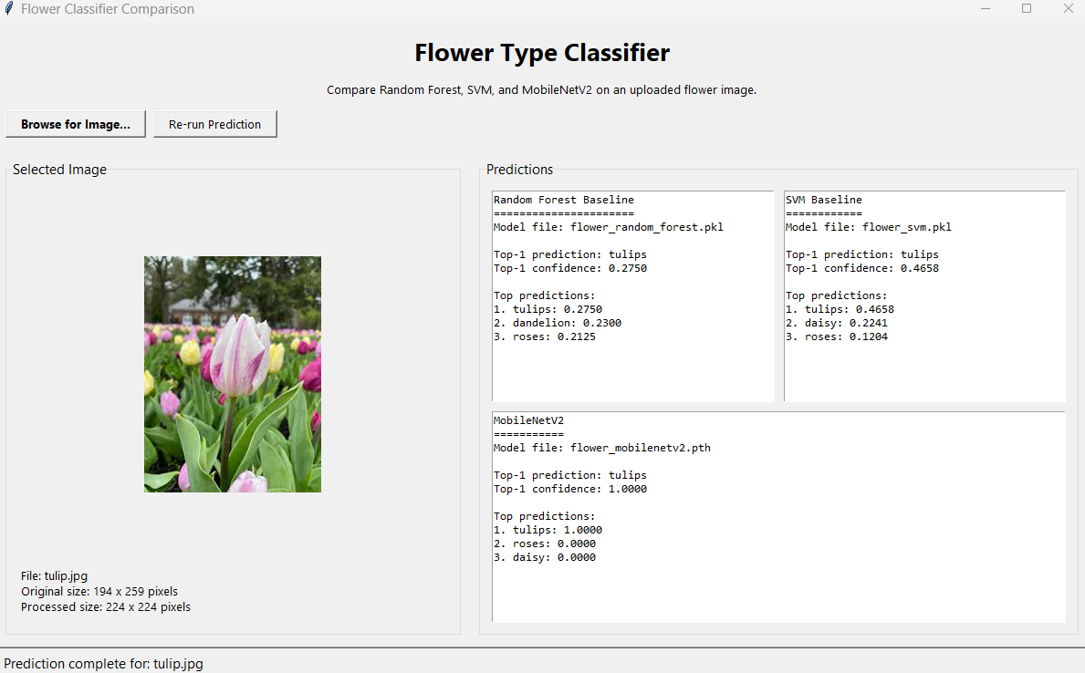

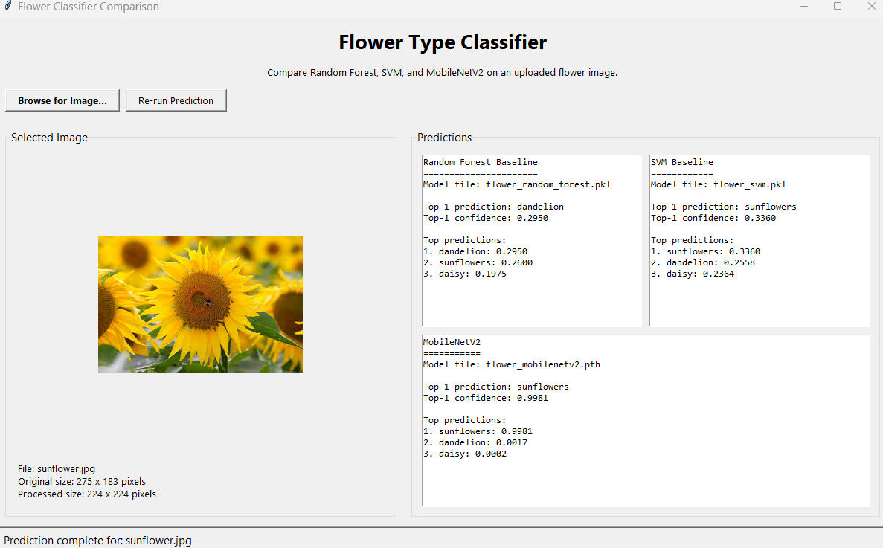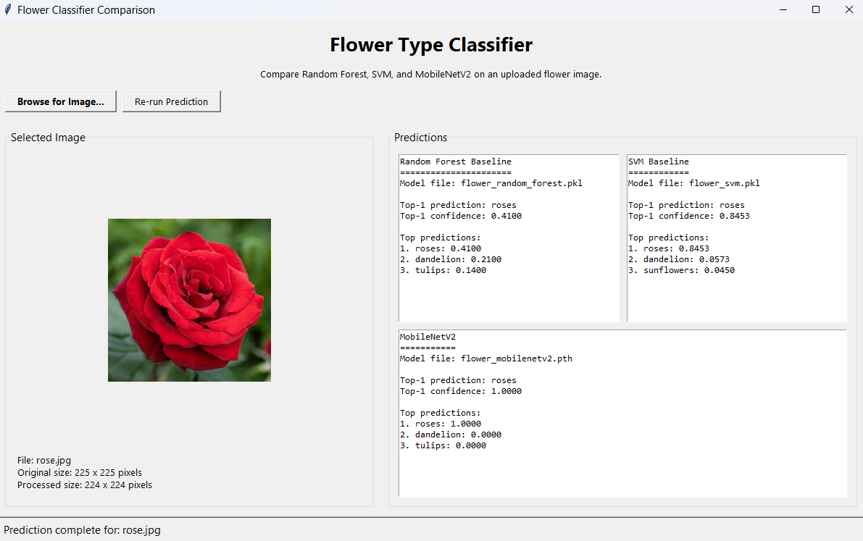
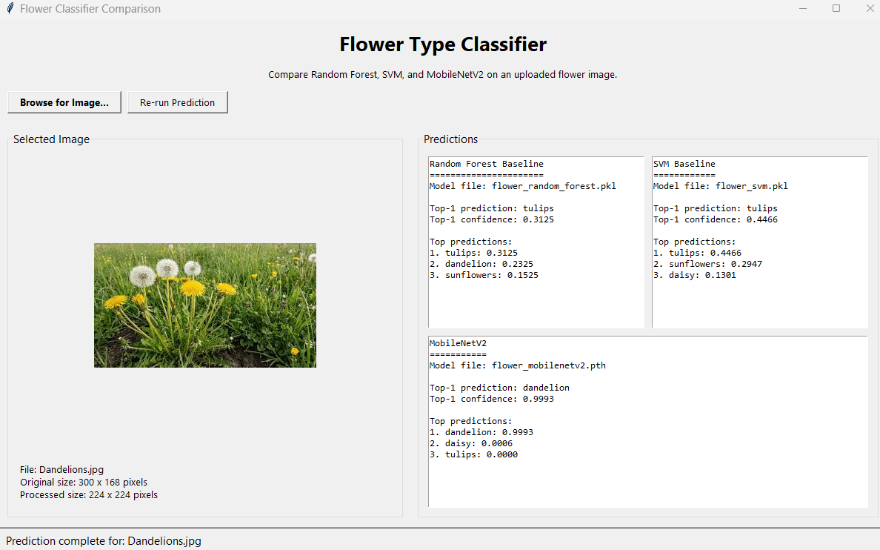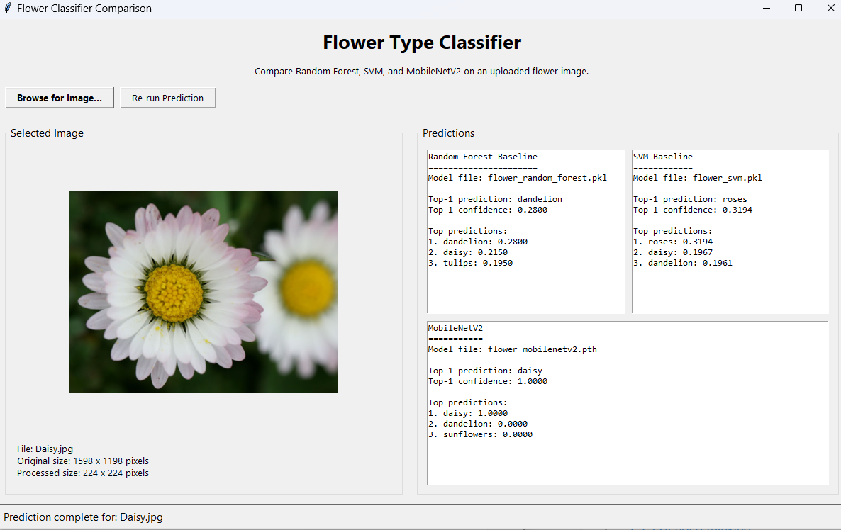

In relation to the literature target, the most meaningful comparison is not a direct claim of state-of-the-art, because the dataset and setup differ, but rather whether the final MobileNetV2 result is consistent with the expectation that an efficient transfer-learning CNN should outperform classical baselines. The reported literature target of 96.67% for MobileNetV2 on another flower dataset therefore serves as a benchmark context rather than a like-for-like comparison.

Ethics, Application, and Robustness

The main ethical issue in this project is over trust. A flower classifier may appear authoritative even when the model is uncertain or wrong. In a casual educational setting, this is low risk. However, in agriculture, environmental monitoring or species identification, incorrect classification could lead to poor decisions, such as recording the wrong species, relying on incorrect plant information, or even a threat to life if a dangerous plant was consumed. The application should therefore be understood as an assistive tool rather than an expert system.

A second issue is dataset bias. The Kaggle flower images may not represent the full variability seen in real-world conditions. Images collected from the web are often cleaner, more centred, and more visually distinctive than field photographs. This can lead to optimistic test performance while reducing generalisation in deployment.

Robustness is also limited by viewpoint, occlusion, background clutter and unusual lighting. Although augmentation helps, the model may still fail when flowers are partly hidden, very small in the frame, or photographed in conditions unlike the training set. The difference between the classical baselines and MobileNetV2 is informative here: the weaker performance of handcrafted methods suggests that simple colour-and-edge descriptors are not robust enough for the full variability of the task, while the stronger MobileNetV2 result suggests that transfer learning captures more discriminative structure.

In application terms, this system could be useful as:
- a lightweight educational identification tool,
- a prototype for a gardening or botany assistant,
- a baseline for more advanced plant-recognition projects.

A sensible next step would be to add a low-confidence warning or threshold so that uncertain predictions are explicitly flagged rather than shown as if they were fully reliable.

Conclusion

This project developed and evaluated a flower image classification tool using both classical computer vision and deep learning. The study compared Random Forest and SVM baselines built on colour histogram and HOG features against a MobileNetV2 transfer-learning model, and then integrated the trained models into a small desktop application.

The main conclusion is that for all five flower types used in this application MobileNetV2 outperformed both classical baselines by a major factor. This supports the broader literature: efficient CNN architectures such as MobileNetV2 are well suited to practical image classification because they combine strong learned representations with relatively low computational cost. At the same time, the classical baselines were still valuable because they provided a meaningful point of comparison and showed how much performance is gained by moving from handcrafted to learned features.

A second conclusion is that model choice should be informed by dataset scale and deployment context. The literature on ViT shows that more modern architectures can excel with massive pretraining, but for a smaller project dataset and an application-oriented deliverable, MobileNetV2 was the more appropriate and defensible choice.

Finally, the application that was developed to allow the user to input their own images of the flower types and follow the same preprocessing pipeline met its requirements well. In this sense, the application successfully translates the trained classifiers into a usable tool. Its main limitation is that it remains a prototype: the interface is functional rather than polished, and the predictions are only as reliable as the underlying models and dataset. Even so, it meets the core functional requirements of the project and demonstrates that the classification system can be deployed in a simple real-world application.

References
Barat, A. &. (2025). ENHANCED FLOWER IMAGE CLASSIFICATION USING MOBILENETV2 WITH OPTIMIZED PERFORMANCE. Jurnal Ilmu Pengetahuan dan Teknologi Komputer, 11, 180-191.
Dosovitskiy, A. B. (2021International Conference on Learning Representations (ICLR 2021)). An image is worth 16x16 words: Transformers for image recognition at scale.
Dumoulin, V. a. (2016). A guide to convolution arithmetic for deep learning. arXiv preprint arXiv:1603.07285.
Sandler, M. H.-C. (2019). MobileNetV2: Inverted residuals and linear bottlenecks. Proceedings of the IEEE/CVF Conference on Computer Vision and Pattern Recognition (CVPR 2019).

